Source ID - 77880799

Source Title - Qiangjiguang Yu Lizishu/High Power Laser and Particle Beams

Agreement URL - <http://www.hplpb.com.cn>

NOTE – Chinese and English TOC should be captured.

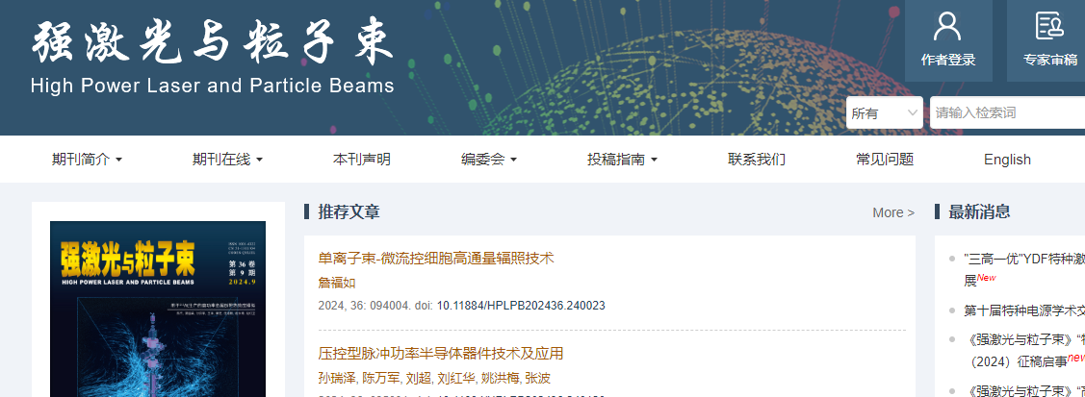

Click to view English translation

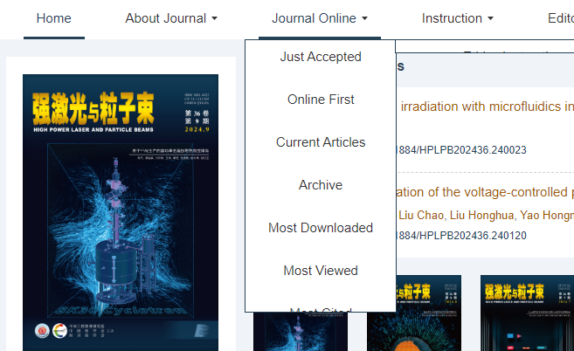

Click current issue

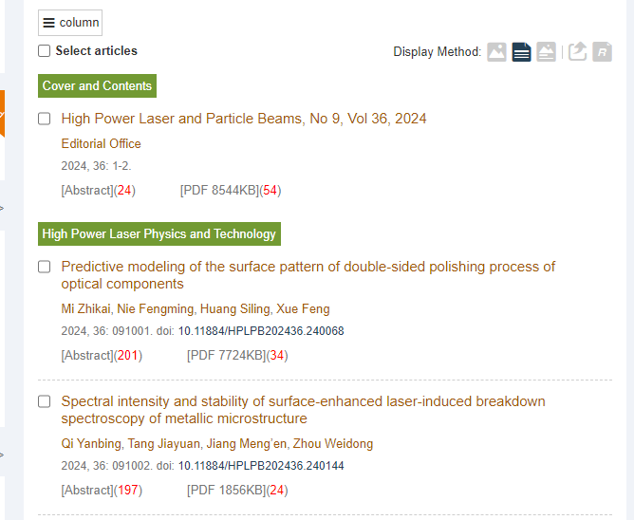

Click to capture meta data

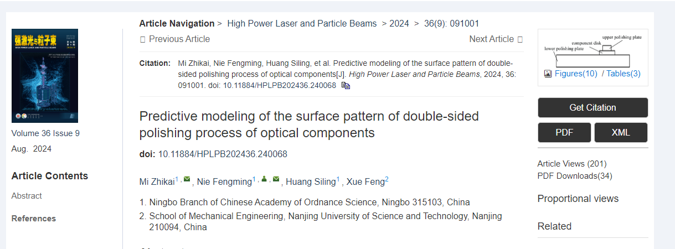

Click to download XML

Click to download PDF

DOI number

Article title

Article number

Volume issue month and year